**Global Music Artists from 2000s**

These artists have defined the music of the decade who also paved way for a new style and a new array of genres. Not only that, but these artists had also presented a huge influence on not just music but to fashion sense and statement as well. They raised up trends and made everyone download their songs into their mp3 players; songs that people would dance to, celebrate to, wept with, cry with and just… connect with. Here are the most popular and influential artists of the decade:

**EMINEM**

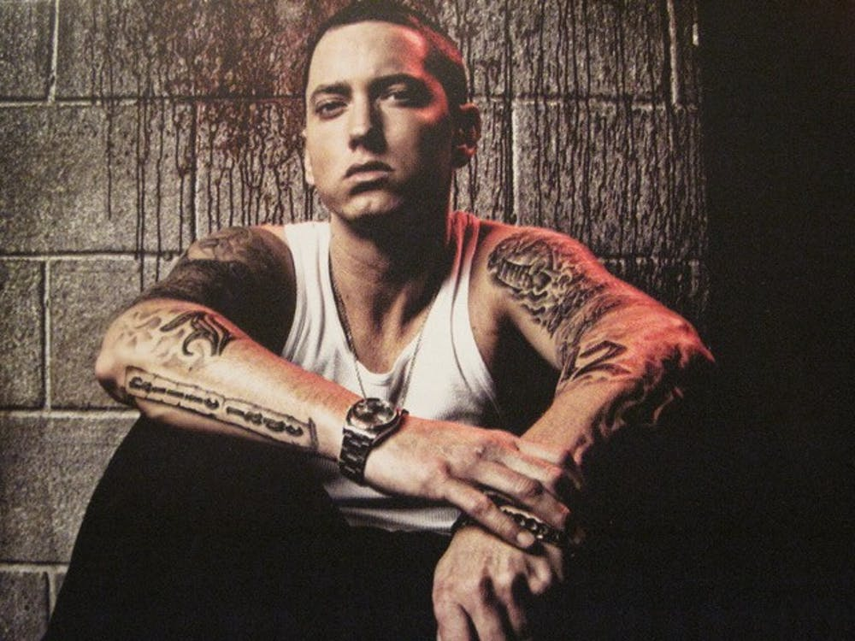

Marshall Bruce Mathers III was born on October 17 in 1972 and is most famously known professionally as his stage name, Eminem. Eminem is known globally as an American rapper, songwriter, record producer, record executive, and actor.

Eminem started out not only in a broken home, but a series of them. The artist we know today was raised by a single mom, lived hand to mouth, on and off welfare, constantly moving from one place to another but still pushed himself to reach his goals. After dropping out of high school, he pushed himself to begin competing in local rap battles, which resulted in earning respect for his craft from his peers and overall music scene. Once he broke into the scene, there was no stopping the “rap God”.

Eminem (Marshall Bruce Mathers III) was recorded as the best-selling artist of the 2000s in the United States. Throughout his entire career, Eminem had earned himself 10 number one albums on the Billboard 200 charts and five number one singles on the Billboard Hot 100 charts. With over 47.4 million albums and 107.5 million singles sold in the U.S. alone, and another 220 million records globally, he is among the world’s best selling artists of all time and is consistently named as one of the greatest and most influential rap artists of all time. Eminem is still to date the only artist to have nine albums consecutively debut at number one on the Billboard 200 charts and was titled as the “King of Hip Hop” by Rolling Stone.

**AVRIL LAVIGNE**

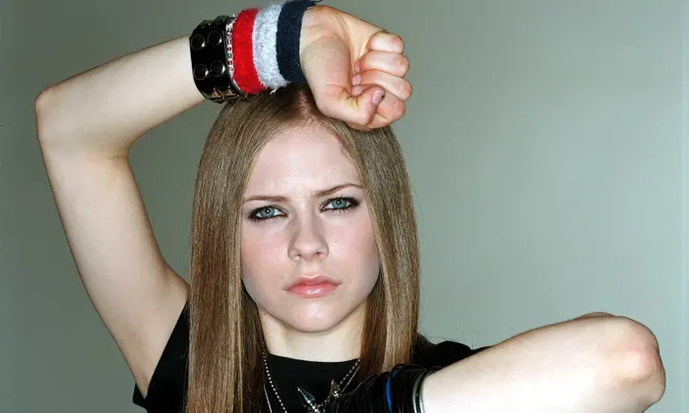

Avril Ramona Lavigne was born on September 27, 1984, in Belleville, Ontario, Canada, and spent most of her childhood in Napanee, Ontario. For more than a decade, Lavigne has enjoyed huge success with her punk-influenced pop sound. She has also branched out in new directions over the years, including starting her own fashion line.

Lavigne sang all the time as a child, much to the chagrin of her two siblings. Raised by deeply religious parents, she first started performing in church choirs. Lavigne learned to play the guitar and began composing her own music as a teenager. At first, she reportedly focused on country music, eventually changing her tune. Leaving high school, she went first to New York City and then to Los Angeles to work with Arista Records.

In 2002, Lavigne released her first album, Let Go. She scored a No. 1 hit with the single "Complicated," a catchy tale of a difficult relationship. More hits, such as "Sk8er Boi" and "I'm With You," soon followed. In addition to her music, Lavigne was deemed a style icon; fans mimicked Lavigne's multicolored hair and copied her skate-punk fashions.

Lavigne's music took a more contemplative turn with 2004's Under My Skin, which did not fare as well as her first album. However, she had two modest hits, "Don't Tell Me" and "Nobody's Home," and one Top 10 track, "My Happy Ending." While many of her songs explored relationship troubles and woes, Lavigne's personal life seemed to be going well. In 2006, she married fellow musician Deryck Whibley, of Canadian pop-punk band Sum 41.

**KANYE WEST**

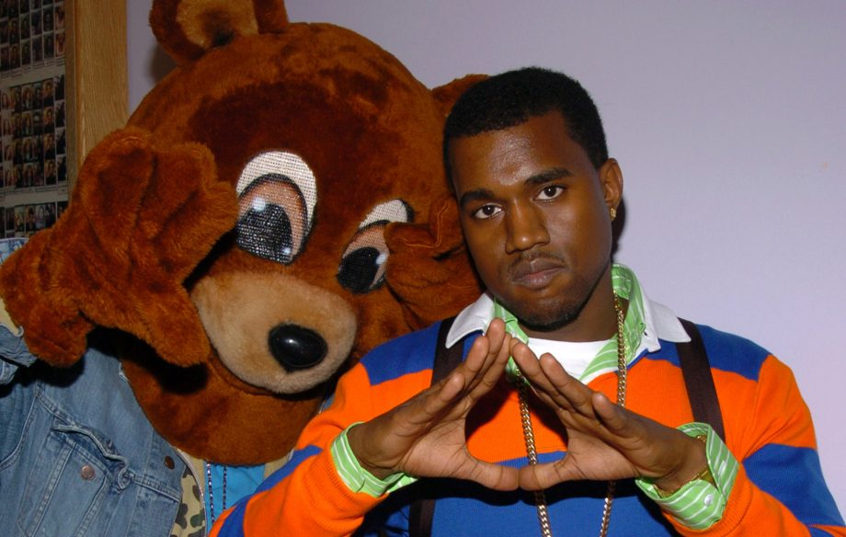

The name has different meanings to different individuals. To some, Kanye is the greatest of all time and a true hero to the world. To others, he is a fool who has continued to make himself more of a fool over the years of his career. And of course there are some who fall in between these two extremes. Well, I am here to tell you that although 'Ye has made some foolish decisions, these do not take away from his genius, and he still deserves at least some recognition for the accomplishments he has made over his time in the spotlight.

In 2004, Kanye West broke onto the scene with his debut album, The College Dropout. The album skyrocket West to fame, with hits like Jesus Walks, Slow Jamz, and the classic Through the Wire, a track West recorded after a near-fatal car crash in which his lower jaw was wired shut. From there, Kanye West's career skyrocketed with his following albums Late Registration (2005), Graduation (2007), 808's and Heartbreak (2008), and My Beautiful Dark Twisted Fantasy (2010).

Each of these albums showed an evolution of West's mindset. While the early albums like Late Registration and Graduation explored West's early life and familial relationships (like in Roses and Hey Mama) as well as his new life as a superstar (songs like Good Life), West's later albums showed more of his life as a successful celebrity and the lifestyle change that took place.

**FALL OUT BOY**

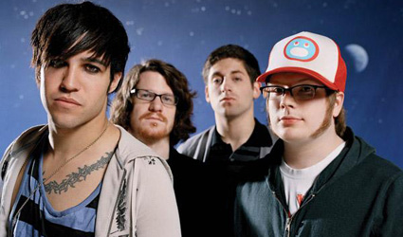

Fall Out Boy rose to the forefront of emo pop in the mid-2000s, selling more than four million albums thanks to the band's tabloid-grabbing bassist, able-voiced frontman, and handful of Top 40 hits. The group's four members first came together in Wilmette, a bedroom community north of Chicago, around 2001. Vocalist/guitarist Patrick Stump, bassist/lyricist Pete Wentz, drummer Andrew Hurley, and guitarist Joe Trohman had all taken part in various bands connected to Chicago's underground hardcore scene. Most notably, Hurley drummed for Racetraitor, the furiously political metalcore outfit whose brief output was both a rallying point and sticking point within the hardcore community. As Fall Out Boy, the quartet used the unbridled intensity of hardcore as a foundation for melody-drenched pop-punk, with a heavy debt to the emo scene. They debuted with a self-released demo in 2001, following it up in May 2002 with a split LP (issued on the Uprising label) that also featured Project Rocket, for which Hurley also drummed. The band remained with the label for the release of a mini-LP, Fall Out Boy's Evening Out with Your Girl, but a bidding war of sorts was already in full swing.

Fall Out Boy eventually signed a deal with Fueled by Ramen, the Florida-based label co-owned by Less Than Jake drummer Vinnie Fiorello, but also received an advance from Island Records to record a proper debut album. The advance came with a right of first refusal for Island on Fall Out Boy's next album, but it also financed the recording of Take This to Your Grave, which occurred at Butch Vig's Smart Studios compound in Madison, Wisconsin, with producer Sean O'Keefe (Lucky Boys Confusion, Motion City Soundtrack) at the helm. Take This to Your Grave appeared in May 2003, and Fall Out Boy earned positive reviews for subsequent gigs at South by Southwest and various tour appearances. Their breakout album, the ambitious From Under the Cork Tree, followed in spring 2005, quickly reaching the Top Ten of Billboard's album chart and spawning two Top Ten hits with "Sugar We're Going Down" and the furiously upbeat "Dance, Dance." The album went double platinum and earned the musicians a Grammy nomination for Best New Artist.

**BRITNEY SPEARS**

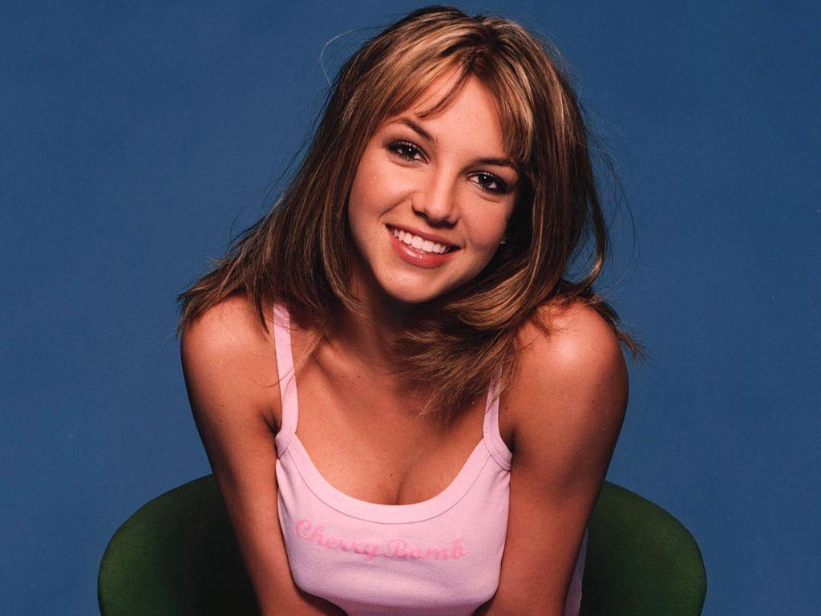

Britney Jean Spears (born December 2, 1981) is an American singer, songwriter, dancer, and actress. Born in McComb, Mississippi and raised in Kentwood, Louisiana, she appeared in stage productions and television series, before signing with Jive Records in 1997. Spears's first two studio albums, ...Baby One More Time (1999) and Oops!... I Did It Again (2000), were global successes and made her the best-selling teenage artist of all-time. Referred to as the "Princess of Pop", Spears is regarded as a pop icon and is credited with influencing the revival of teen pop during the late 1990s and early 2000s.

Spears adopted more mature and provocative themes for her next two studio albums, Britney (2001) and In the Zone (2003), and made her feature film debut in a starring role in Crossroads (2002). Following a series of heavily publicized personal struggles and erratic public behavior, Spears's career was interrupted, before the release of her fifth studio album Blackout (2007), which is often critically referred to as her best work. Her erratic behavior and hospitalizations led Spears to be placed on a still ongoing conservatorship. She returned to the top of record charts with her sixth and seventh studio albums, Circus (2008) and Femme Fatale (2011), respectively. In 2012, Forbes reported that Spears was the highest paid female musician of the year, with earnings of $58 million, having last topped the list in 2002. During the promotion of her eighth and ninth studio albums, Britney Jean (2013) and Glory (2016), Spears embarked on a four-year concert residency, Britney: Piece of Me, at Planet Hollywood Resort & Casino in Las Vegas, which became one of the highest-grossing residencies of all-time. In 2019, Spears announced an indefinite career hiatus and was later admitted involuntarily into a mental health facility by her conservator, leading to a court-led investigation into malpractice conducted by Spears's team.

Spears has scored six number one albums on the Billboard 200, making her the third best performing female artist on the chart.[3] Five of Spears's singles have reached number one on the US Billboard Hot 100: "...Baby One More Time", "Womanizer", "3", "Hold It Against Me", and "S&M". Other singles, "Oops!... I Did It Again" and "Toxic", topped the charts in most countries. With "3" in 2009 and "Hold It Against Me" in 2011, she became the second artist after Mariah Carey in the Hot 100's history to debut at number one with two or more songs. Spears has earned numerous awards and accolades, including a Grammy Award; seven Guinness World Records; six MTV Video Music Awards, including the Michael Jackson Video Vanguard Award; seven Billboard Music Awards, including the Millennium Award; the inaugural Radio Disney Icon Award; and a star on the Hollywood Walk of Fame. Billboard ranked her as the eighth-biggest artist of the 2000s decade. One of the world's best-selling music artists, Spears has sold over 150 million records worldwide and more than 70 million records in United States, including 36.9 million digital singles and 33.6 million digital albums. In the United States, Spears is the fourth best-selling female album artist of the Nielsen SoundScan era as well as the best-selling female album artist of the 2000s.

In 2004, Spears launched a perfume brand with Elizabeth Arden, Inc.; sales exceeded US$1.5 billion as of 2012. Spears has topped the list of most searched celebrities seven times in 12 years, a record since the inception of the internet.

**MY CHEMICAL ROMANCE**

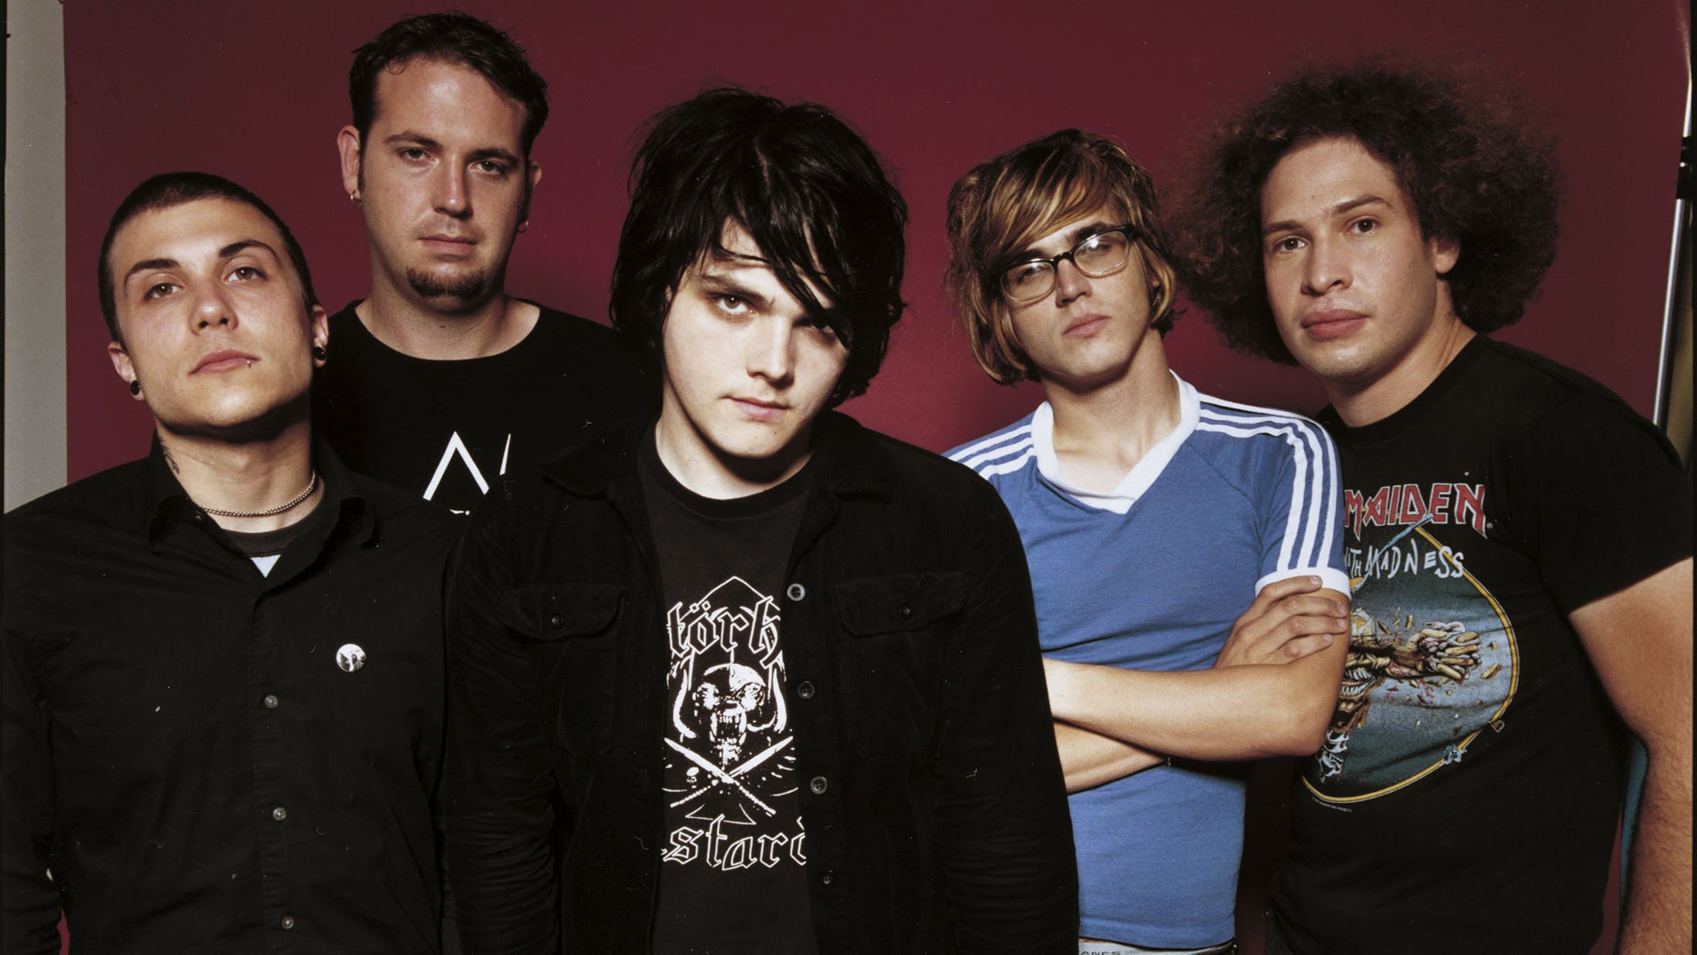

My Chemical Romance (commonly abbreviated MCR or shortened to My Chem) was an American rock band from Newark, New Jersey, active from 2001 to 2013. The band's best-known lineup consisted of lead vocalist Gerard Way, guitarists Ray Toro and Frank Iero, bassist Mikey Way and drummer Bob Bryar, accompanied by keyboardist James Dewees. Founded by Gerard, Mikey, Toro, and Matt Pelissier (and later joined by Iero), the band signed to Eyeball Records and released their debut album, I Brought You My Bullets, You Brought Me Your Love, in 2002. They signed with Reprise Records the next year and released their major label debut, Three Cheers for Sweet Revenge, in 2004. Shortly after the album's release, Pelissier was replaced by Bob Bryar. A commercial success, the album was awarded platinum status over a year later.

The band eclipsed their previous success with their 2006 concept album, The Black Parade, which gained generally favorable reviews among music critics and was certified double platinum in the United States and the United Kingdom, the band's only double platinum. After the departure of long-time drummer Bob Bryar in March 2010, the band released their fourth studio album, Danger Days: The True Lives of the Fabulous Killjoys, in November that same year, to positive reviews. After the addition of touring keyboardist James Dewees in 2012 and the release of Conventional Weapons, a series of singles recorded in 2009, released over the course of five months, the band announced its break-up on March 22, 2013, one month after the final release in the Conventional Weapons series. After the band's split, a greatest hits album entitled May Death Never Stop You was released in March 2014.A tenth anniversary reissue of The Black Parade was released in September 2016 titled The Black Parade/Living with Ghosts.

**CHRISTINA AGUILERA**

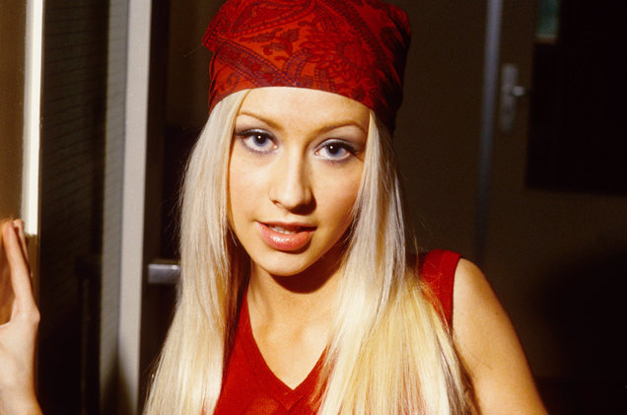

Christina María Aguilera (/ˌæɡwɪˈlɛərə/, Spanish: [aɣiˈleɾa];born December 18, 1980) is an American singer, songwriter, actress and television personality. Her accolades include five Grammy Awards, one Latin Grammy Award, and a star on the Hollywood Walk of Fame. Aguilera ranked at number 58 on Rolling Stone's list of 100 Greatest Singers of All Time in 2008, and was included on Time's annual list of the 100 most influential people in the world in 2013. With estimated sales of 75 million records, she is one of the world's best-selling music artists.

Born in Staten Island of New York City and raised in Pennsylvania, Aguilera appeared on television shows in her early years before gaining a recording contract with RCA Records in 1998. Her self-titled debut album, released in 1999, reached number one in the US and spawned three US number-one singles: "Genie in a Bottle", "What a Girl Wants", and "Come On Over Baby (All I Want Is You)". While recognized as a prominent figure in the contemporary teen pop scene, Aguilera sought to assume artistic control with Stripped (2002) and its lead single "Dirrty", which displayed her sexually emancipated persona and generated considerable controversy. The second single from the album, "Beautiful", received favorable response for its empowering lyrics and became an anthem for the LGBT community.

Aguilera scored her second US number-one album with Back to Basics (2006), which drew inspiration from early 20th-century jazz, soul, and blues, and spawned the top-ten singles "Ain't No Other Man", "Hurt", and "Candyman". Her next three albums, Bionic (2010), Lotus (2012), and Liberation (2018), all experimented with various musical styles and reached the top ten in the US. Besides solo materials, Aguilera earned chart-topping entries with collaborations including "Lady Marmalade", "Moves like Jagger", "Feel This Moment", and "Say Something". Alongside her music career, Aguilera starred in the film Burlesque (2010) and was a coach on six seasons of the singing competition television series The Voice from 2011 to 2016.

**JUSTIN TIMBERLAKE**

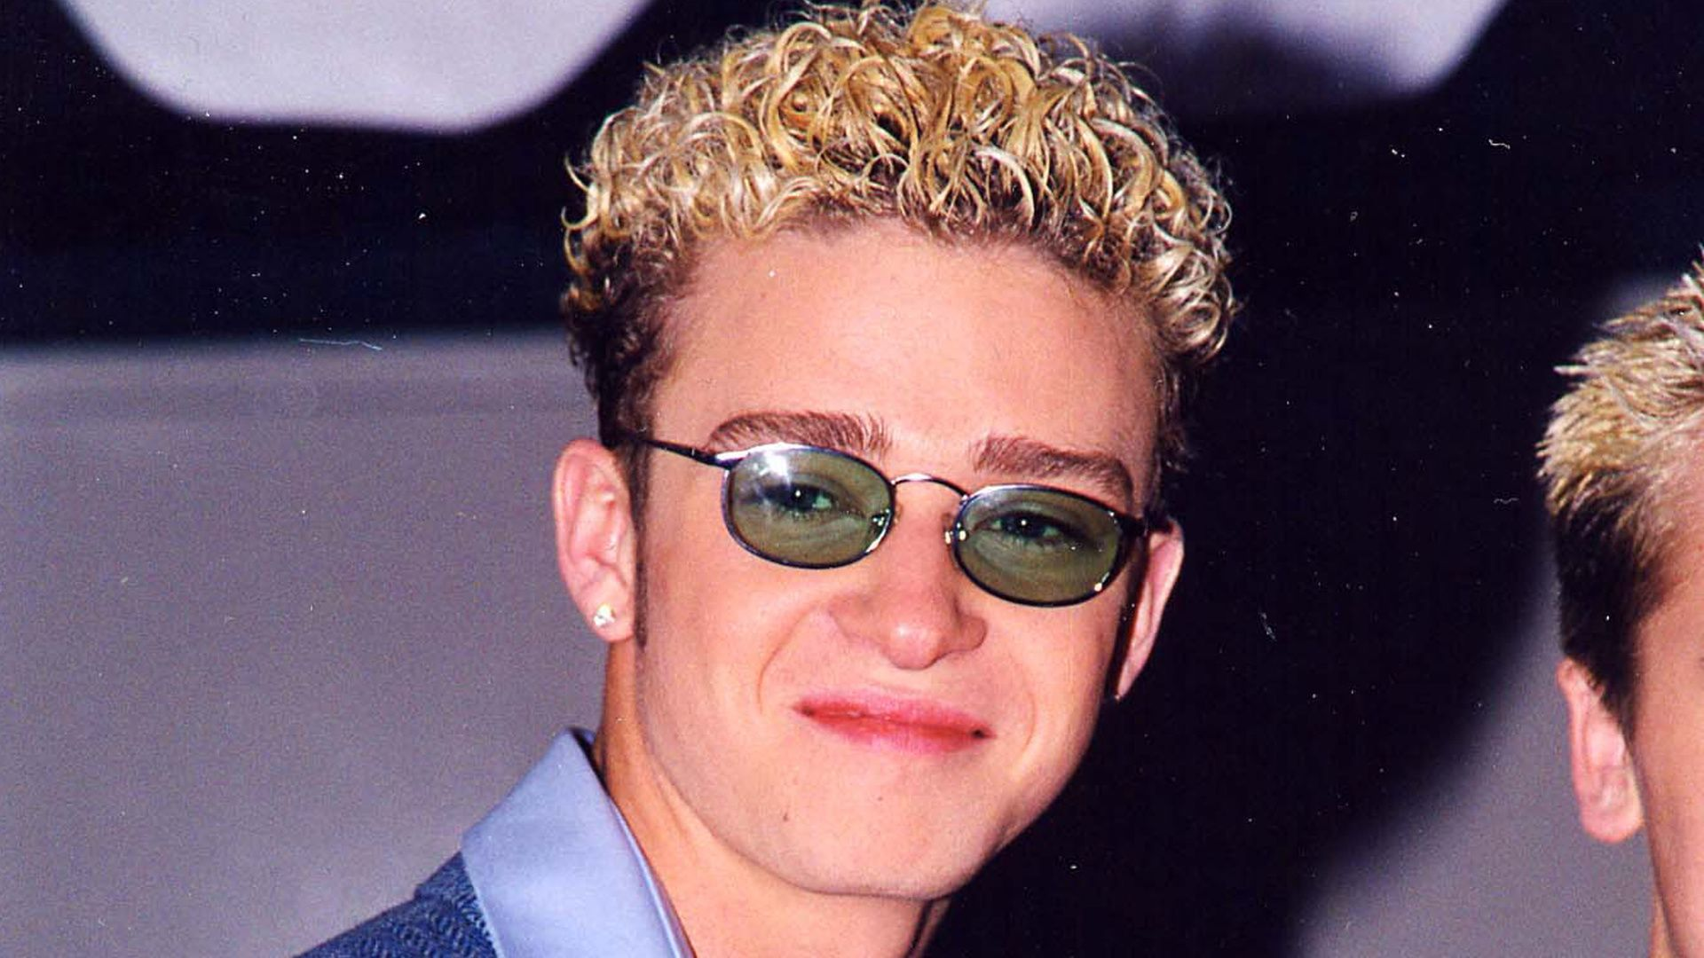

Justin Randall Timberlake (born January 31, 1981), often known by his initials, JT, is an American singer, songwriter, actor, dancer and record producer.Born and raised in Tennessee, he appeared on the television shows Star Search and The All-New Mickey Mouse Club as a child. In the late 1990s, Timberlake rose to prominence as one of the two lead vocalists and youngest member of NSYNC, which eventually became one of the best-selling boy bands of all time. Timberlake began to adopt a more mature image as an artist with the release of his debut solo album, the R&B-focused Justified (2002), which yielded the successful singles "Cry Me a River" and "Rock Your Body", and earned his first two Grammy Awards.

His critically acclaimed second album FutureSex/LoveSounds (2006), characterized by its diversity in music genres, debuted atop the U.S. Billboard 200 and produced the Hot 100 number-one singles "SexyBack", "My Love", and "What Goes Around... Comes Around". Established as a solo artist worldwide, his first two albums both exceeded sales of 10 million copies, and he continued producing records and collaborating with other artists. From 2008 through 2012, Timberlake focused on his acting career, effectively putting his music career on hiatus. He held starring roles in the films The Social Network, Bad Teacher, Friends with Benefits, and In Time.

Timberlake resumed his music career in 2013 with his third and fourth albums The 20/20 Experience and The 20/20 Experience – 2 of 2, exploring neo soul styles, partly inspired by the expansive song structures of 1960s and 1970s rock. The former became the best-selling album of the year in the US with the largest sales week, and spawned the top-three singles "Suit & Tie" and "Mirrors", while the latter produced the top-ten song "Not a Bad Thing". For his live performances, including the eponymous concert tour for the albums, he began performing with his band The Tennessee Kids, composed by instrumentalists and dancers. Timberlake voiced Branch in DreamWorks Animation's Trolls (2016), whose soundtrack includes his fifth Billboard Hot 100 chart-topping single, "Can't Stop the Feeling!". His fifth studio album Man of the Woods (2018) became his fourth number-one album in the US. The album was supported by the two top ten singles, "Filthy" and "Say Something". Man of the Woods concluded 2018 as the sixth best-selling album of the year.

Throughout his solo career, Timberlake has sold over 32 million albums and 56 million singles globally, making him one of the world's best-selling music artists. Often cited as a pop icon, Timberlake is the recipient of numerous awards and accolades, including ten Grammy Awards, four Emmy Awards, three Brit Awards, and nine Billboard Music Awards. According to Billboard in 2017, he is the best performing male soloist in the history of the Mainstream Top 40. Time named him one of the 100 most influential people in the world in 2007 and 2013. His other ventures include record label Tennman Records, fashion label William Rast, and the restaurants Destino and Southern Hospitality.

**LUDACRIS**

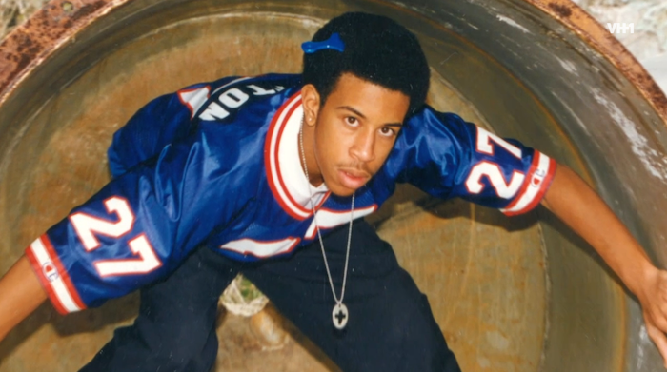

Ludacris is one of the most influential rappers of all time, patenting the “Dirty South” sound alongside Big Boy, Andre 3000 and OutKast. In his decades in the business, he’s amassed Grammy Awards, MTV Awards, and Screen Actors Guild Awards. He’s topped Forbes lists and transitioned to an actor in one of the most successful action movie franchises of all time.

Ludacris was born Christopher Brian Bridges on September 11, 1977, from two parents who were college students. They split when he was little, but he didn’t have a turbulent upbringing until moving to Atlanta. Ludacris remained on good terms with both his mother and father throughout his entire life. At 12 years old, he moved to Atlanta. This forced him to quit his rap group Loudmouth Hooligans, but his career was far from over.

Ludacris was about 21 years old when he finally got his first brush with fame. He contributed a guest verse on Timbaland's first album Tim's Bio: Life from Da Basement. During this time, the rapper was working with Jermain Dupri, Bangladesh, and Organized Noise on his debut Icognegro.

Though the '90s were a time where the record industry was booming, and artists regularly sold millions of copies in the first week, Luda decided to take his career into his own hands. This was bold. He released his debut on Disturbing Tha Peace, his very own label. The album didn't sell well, but Luda trucked on.

In the late 90s, Ludacris was working as a DJ at renowned rap station Hot 97.5 as Chris Lova Lova. By 2000, his days at the radio station were behind him because he signed a deal with Def Jam Records. His debut Back for the First Time included songs from his initial self-release but wasn't subject to the same poor sales. Instead, it skyrocketed to No. 4 on the Billboard 200, spawning the career defining singles "Southern Hospitality" and "What's Your Fantasy."

**BLINK-182**

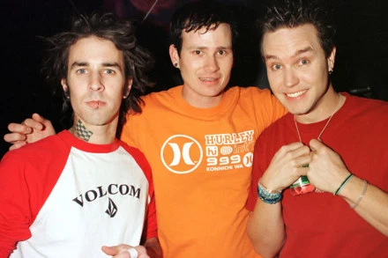

Formed in Poway, California, in 1992 — when bassist Mark Hoppus' sister introduced him to guitarist Tom DeLonge, who was playing in a band called Big Oily Men — they recruited drummer Scott Raynor and began jamming out in DeLonge's garage. Originally saddled with the name Duck Tape, DeLonge rechristened the band as Blink, and they recorded a pair of demos (songs from the demos would later resurface on the band's first two albums). Drawing the attention of local label Cargo Music, they released their debut album, Cheshire Cat, in 1994. And though the album never made much of an impact commercially, it's often cited by bands and fans as an iconic release. Soon after, they drew the ire of an Irish band also named Blink, so they were forced to change their name to Blink-182.

In 1997, they released Dude Ranch, and thanks to the success of singles like "Dammit" and "Josie," the album sold more than a million copies. While touring in support of the record, they parted was with drummer Raynor (under somewhat mysterious circumstances) and asked Travis Barker — who was drumming with tourmates the Aquabats — to fill in behind the kit for the remainder of the dates. Turns out, he would never leave.

In 1999, Blink broke-through to the mainstream with Enema of the State, a roiling mix of pop punk and punnery that featured porn star Janine Lindemulder on the cover. Thanks to a string of successful singles (and over-the-top videos), Enema went on to sell more than 15 million albums worldwide, making Blink the biggest punk act on the planet. Accordingly, they toured the globe (shows were recorded for their The Mark, Tom, and Travis Show live album) and even made an appearance in the raunchy blockbuster "American Pie."

**BEYONCE**

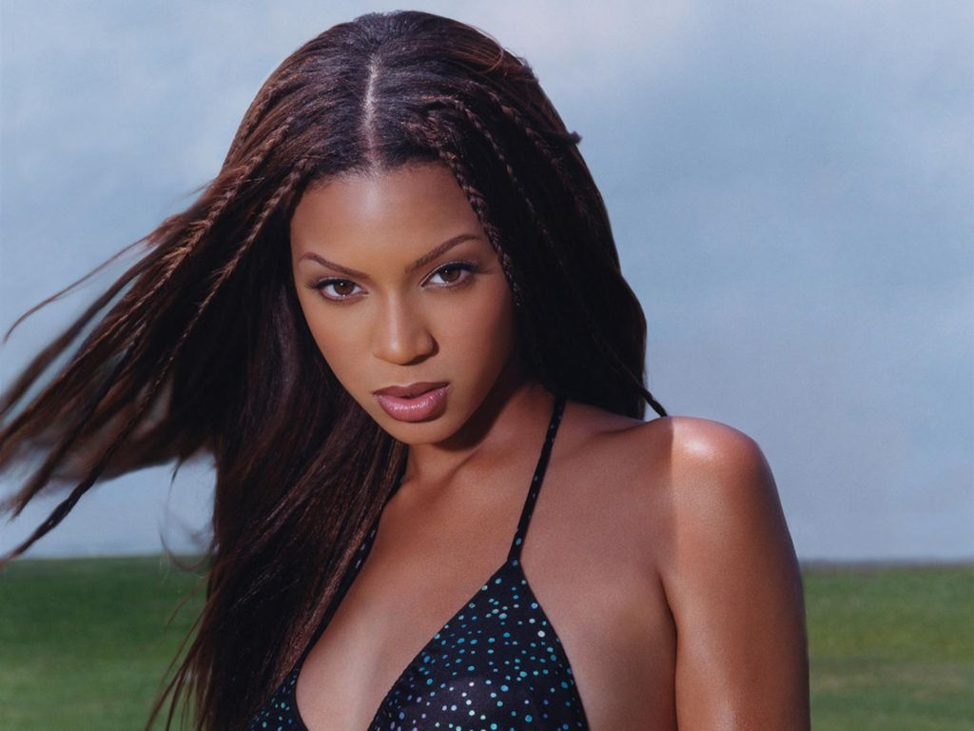

Beyoncé Giselle Knowles-Carter (/biːˈjɒnseɪ/ bee-YON-say; born September 4, 1981) is an American singer, songwriter and actress. Born and raised in Houston, Texas, Beyoncé performed in various singing and dancing competitions as a child. She rose to fame in the late 1990s as lead singer of the R&B girl-group Destiny's Child, one of the best-selling girl groups in history. Their hiatus saw the release of her first solo album, Dangerously in Love (2003), which debuted at number one on the US Billboard 200 chart and earned her five Grammy Awards. The album also featured the US Billboard Hot 100 number-one singles "Crazy in Love" and "Baby Boy".

Following the break-up of Destiny's Child in 2006, she released her second solo album, B'Day, which contained her fourth solo number-one song in the US, "Irreplaceable". Beyoncé also continued her acting career with starring roles in The Pink Panther (2006), Dreamgirls (2006), and Obsessed (2009). Her marriage to rapper Jay-Z and her portrayal of Etta James in Cadillac Records (2008) influenced her third album, I Am... Sasha Fierce (2008), which saw the introduction of her alter-ego, Sasha Fierce, and earned a record-setting six Grammy Awards in 2010, including Song of the Year for "Single Ladies (Put a Ring on It)". After splitting from her manager and father Mathew Knowles in 2010, she released 4 in 2011, which explored a mellower tone and was influenced by 1970s funk, 1980s pop, and 1990s soul. Her critically acclaimed eponymous album, released in 2013 with no prior announcement, was even more experimental in its production and exploration of darker themes. Lemonade (2016), one of her most personal and political work to date, received widespread critical acclaim and became the best-selling album of 2016. In 2018, she released Everything Is Love, a collaborative album with her husband, Jay-Z, as The Carters.

Throughout her career, Beyoncé has sold over 100 million records worldwide as a solo artist and a further 60 million records with Destiny's Child, making her one of the best-selling music artists of all time. The Recording Industry Association of America recognized Beyoncé as the Top Certified Artist in America during the 2000s decade. In 2009, Billboard named her the Top Radio Songs Artist of the Decade and the Top Female Artist of the 2000s decade. Among numerous awards and accolades, Beyoncé has won 23 Grammy Awards and is the most nominated woman in the award's history. She is the most awarded artist at the MTV Video Music Awards, with 24 wins, including the Michael Jackson Video Vanguard Award. In 2014, she became the highest-paid black musician in history and was listed among Time's 100 most influential people in the world for a second year in a row. Forbes ranked her as the most powerful female in entertainment on their 2015 and 2017 lists, and in 2016, she occupied the sixth place for Time's Person of the Year.With the release of Lemonade, Beyoncé became the first and only musical act in Billboard chart history to debut at number one with their first six solo studio albums.

**LINKIN PARK**

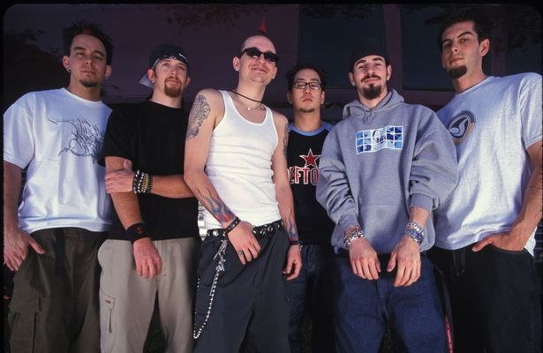

Linkin Park is an American rock band from Agoura Hills, California. The band's current lineup comprises vocalist/keyboardist/rhythm guitarist Mike Shinoda, lead guitarist Brad Delson, bassist Dave Farrell, DJ/keyboardist Joe Hahn, and drummer Rob Bourdon, all of whom are founding members. Vocalists Mark Wakefield and Chester Bennington and bassist Kyle Christner are former members of the band.

Formed in 1996, Linkin Park rose to international fame with their debut studio album, Hybrid Theory (2000), which was certified diamond by the RIAA in 2005, and multi-platinum in several other countries. Their second album, Meteora (2003), continued the band's success, topping the Billboard 200 album chart in 2003, and was followed by extensive touring and charity work.[2] Having adapted nu metal and rap metal to a radio-friendly yet densely layered style in their first two albums, the band explored other genres on their third album, Minutes to Midnight (2007). The album topped the Billboard charts and had the third-best debut week of any album that year.

Linkin Park continued to explore a wider variation of musical types in their fourth album, A Thousand Suns (2010), layering their music with more electronic sounds. The band's fifth album, Living Things (2012), combined musical elements from all of their previous records. Their sixth album, The Hunting Party (2014), returned to a heavier rock sound, and their seventh album, One More Light (2017), was a more electronic and pop-oriented record.

Linkin Park is among the best-selling bands of the 21st century and the world's best-selling music artists overall, having sold more than 70 million albums worldwide. They have won two Grammy Awards, six American Music Awards, four MTV Video Music Awards and three World Music Awards. In 2003, MTV2 named Linkin Park the sixth-greatest band of the music video era and the third-best of the new millennium. Billboard ranked Linkin Park No. 19 on the Best Artists of the Decade chart. In 2012, the band was voted as the greatest artist of the 2000s in a Bracket Madness poll on VH1. In 2014, the band was declared as "The Biggest Rock Band in the World Right Now" by Kerrang!.

Linkin Park went into an indefinite hiatus after longtime lead vocalist Bennington died from suicide by hanging on July 20, 2017.

**USHER**

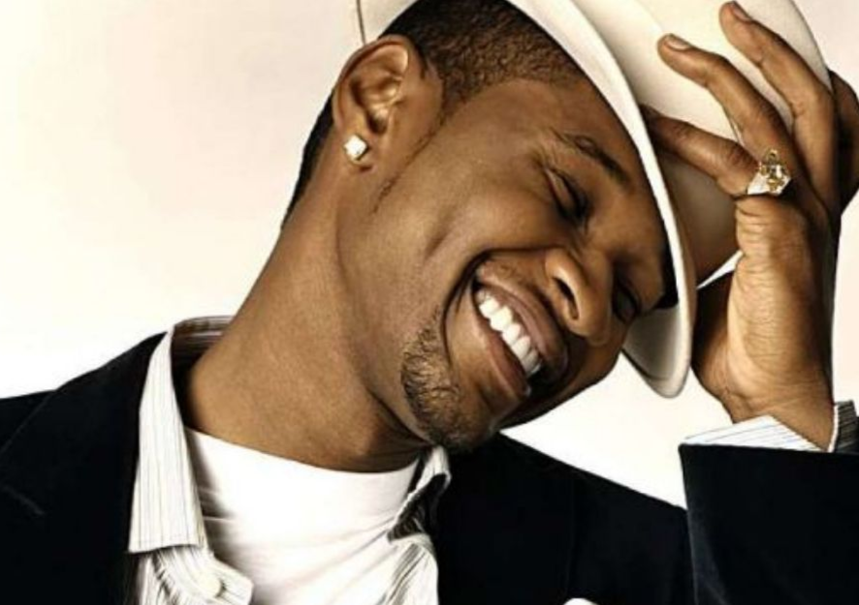

Usher Raymond IV (born October 14, 1978) is an American singer, songwriter and dancer. He was born in Dallas, Texas, but raised in Chattanooga, Tennessee until moving to Atlanta, Georgia. At the age of 12, his mother put him in local singing competitions, before catching the attention of a music A&R from LaFace Records. He released his self-titled debut album, Usher (1994) but rose to fame in the late 1990s with the release of his second album My Way (1997). It spawned his first U.S. Billboard Hot 100 number-one single, "Nice & Slow", among top-two singles "You Make Me Wanna..." and "My Way". 8701 (2001) produced the number-one singles "U Remind Me" and "U Got It Bad", as well as top-three single "U Don't Have to Call". It sold eight million copies worldwide and won his first two Grammy Awards as Best Male R&B Vocal Performance in 2002 and 2003.

Confessions (2004) established him as one of the best-selling musical artists of the 2000s decade, selling 20 million copies worldwide. Bolstered by its four consecutive Billboard Hot 100 number one singles—"Yeah!", "Burn", "Confessions Part II" and "My Boo"—it has been certified Diamond by the RIAA. Here I Stand (2008) and Raymond v. Raymond (2010) both debuted atop of the Billboard 200 chart and respectively produced the number-one singles "Love in This Club" and "OMG". The EP, Versus, produced top-five single "DJ Got Us Fallin' in Love", before releasing top-fifteen single "More". Looking 4 Myself (2012) also debuted atop the Billboard 200 chart with the top-ten single "Scream". The R&B ballads "There Goes My Baby" and "Climax" received Grammy Awards in 2011 and 2013. "I Don't Mind" also reached the top-fifteen in 2014, while Hard II Love (2016) peaked at five on the Billboard 200 chart.

Usher has sold 23.8 million albums and 38.2 million digital songs in the United States. Internationally, he has sold 75 million records worldwide, making him one of the best-selling music artists of all time. Usher has won numerous awards and accolades including eight Grammy Awards and 18 Billboard Music Awards. At the end of 2009, Billboard named him the second most successful artist of the 2000s decade, the number-one Hot 100 artist of the 2000s decade, and ranked Confessions as the top solo album of the 2000s decade. Billboard also placed him at number 6 on their list of Top 50 R&B/Hip-Hop Artists of the Past 25 Years. Usher has attained nine US Hot 100 number-one singles. Considered an icon and sex symbol, he has had TV and film appearances and seen inductions into the Georgia Music Hall of Fame and Hollywood Walk of Fame. He owns the record label Raymond-Braun Media Group (RBMG), a joint venture with talent manager Scooter Braun that includes Canadian singer Justin Bieber.

**FOO FIGHTERS**

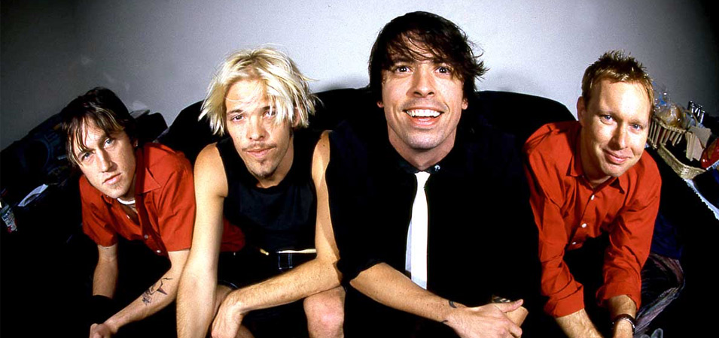

Foo Fighters is an American rock band, formed in Seattle, Washington, in 1994. It was founded by Nirvana drummer Dave Grohl as a one-man project following the dissolution of Nirvana after the suicide of Kurt Cobain. The group got its name from the UFOs and various aerial phenomena that were reported by Allied aircraft pilots in World War II, which were known collectively as "foo fighters".

Prior to the release of Foo Fighters' 1995 debut album Foo Fighters, which featured Grohl as the only official member, Grohl recruited bassist Nate Mendel and drummer William Goldsmith, both formerly of Sunny Day Real Estate, as well as Nirvana touring guitarist Pat Smear to complete the lineup. The band began with performances in Portland, Oregon. Goldsmith quit during the recording of the group's second album, The Colour and the Shape (1997), when most of the drum parts were re-recorded by Grohl himself. Smear's departure followed soon afterward, though he would appear as a guest with the band frequently starting in 2006, and would rejoin as an official full-time member in 2011.

They were replaced by Taylor Hawkins and Franz Stahl, respectively, although Stahl was fired before the recording of the group's third album, There Is Nothing Left to Lose (1999). The band briefly continued as a trio until Chris Shiflett joined as the band's lead guitarist after the completion of There Is Nothing Left to Lose. The band released its fourth album, One by One, in 2002. The group followed that release with the two-disc In Your Honor (2005), which was split between acoustic songs and heavier material. Foo Fighters released its sixth album, Echoes, Silence, Patience & Grace, in 2007. The band's seventh studio album, Wasting Light, produced by Butch Vig, was released in 2011, in which Smear returned as a full member. In November 2014, the band's eighth studio album, Sonic Highways, was released as an accompanying soundtrack to the Grohl-directed 2014 miniseries of the same name. On September 15, 2017, the band released their ninth studio album, Concrete and Gold, which became their second to reach number one in the United States and was the band's first studio album to feature longtime session and touring keyboardist Rami Jaffee as a full member.

Over the course of the band's career, four of its albums have won Grammy Awards for Best Rock Album. As of 2015, the band has sold 12 million copies in the United States alone.

**COLDPLAY**

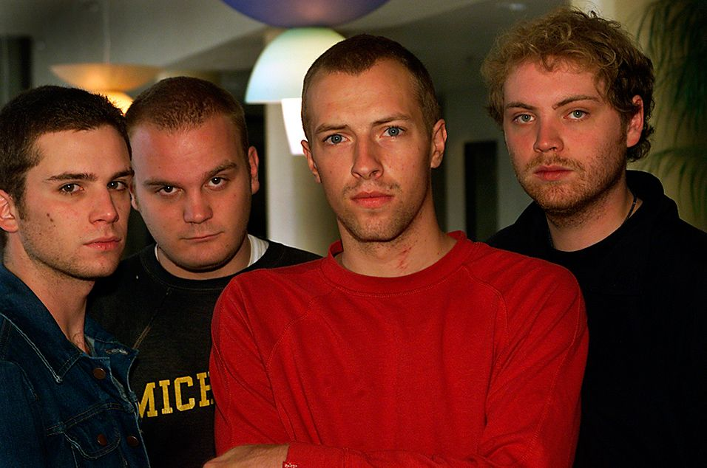

Coldplay are a British rock band formed in London in 1996. The four members – which include lead vocalist/pianist Chris Martin, lead guitarist Jonny Buckland, bassist Guy Berryman and drummer Will Champion – were at University College London and came together from 1996 to 1998. During these two years, the band changed names from Pectoralz, to Starfish, and finally, to Coldplay. Creative director and former manager Phil Harvey is often referred to as the fifth member by the band. They recorded and released two EPs: Safety in 1998 and The Blue Room in 1999. The latter was their first release on a major label, after signing to Parlophone.

Coldplay achieved worldwide fame with the release of the song "Yellow" in 2000, followed in the same year by their debut album Parachutes, which was nominated for the Mercury Prize. The band's second album, A Rush of Blood to the Head (2002), was released to critical acclaim and won many awards, including NME's Album of the Year. Their next release, X&Y, the best-selling album worldwide in 2005, received mostly positive reviews, though some critics felt it was inferior to its predecessor. Their fourth studio album, Viva la Vida or Death and All His Friends (2008), the best-selling album worldwide of 2008, was produced by Brian Eno and released to largely positive reviews, earning three Grammy Awards. In October 2011, Coldplay released their fifth studio album, Mylo Xyloto, which topped the charts in over 34 countries, was the UK's best-selling rock album of 2011, and received mixed reviews. In 2014, they released their sixth album, Ghost Stories, which also received mixed reviews and topped several national album charts. In December 2015, the band released their seventh album, A Head Full of Dreams, which reached the top two in most major markets, but received generally mixed reviews.

Coldplay have won numerous awards throughout their career, including nine Brit Awards, six MTV Video Music Awards, seven MTV Europe Music Awards and seven Grammy Awards from 29 nominations. They have sold more than 100 million records worldwide, making them one of the world's best-selling music artists. Three of their albums: Parachutes, A Rush of Blood to the Head and X&Y are among the best-selling albums in UK chart history. In December 2009, Rolling Stone readers voted the group the fourth-best artist of the 2000s. Coldplay have supported various social and political causes, such as Oxfam's Make Trade Fair campaign and Amnesty International. They have also performed at charity projects, including Band Aid 20, Live 8, Global Citizen Festival, Sound Relief, Hope for Haiti Now: A Global Benefit for Earthquake Relief, One Love Manchester, The Secret Policeman's Ball, Sport Relief and the UK Teenage Cancer Trust.

**GREEN DAY**

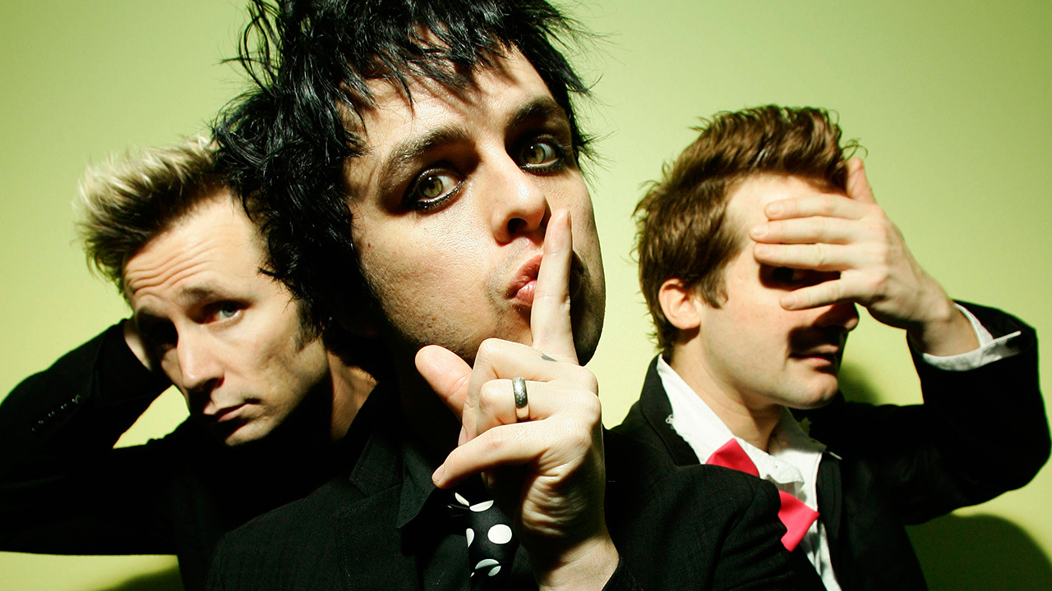

Green Day is an American rock band formed in 1986 by lead vocalist and guitarist Billie Joe Armstrong and bassist Mike Dirnt. For much of the band's career, they have been a trio with drummer Tré Cool, who replaced John Kiffmeyer in 1990 prior to the recording of the band's second studio album, Kerplunk (1991).

Green Day was originally part of the punk scene at the DIY 924 Gilman Street club in Berkeley, California. The band's early releases were with the independent record label Lookout! Records. In 1994, their major label debut Dookie, released through Reprise Records, became a breakout success and eventually shipped over 10 million copies in the U.S., Green Day is credited alongside fellow California punk bands including Sublime, Bad Religion, The Offspring and Rancid with popularizing mainstream interest in punk rock in the United States.

Though Insomniac (1995), Nimrod (1997) and Warning (2000), did not match the success of Dookie, Insomniac and Nimrod reached double platinum and Warning achieved gold status. Green Day's seventh album, American Idiot (2004), a rock opera, found popularity with a younger generation, selling six million copies in the U.S. 21st Century Breakdown was released in 2009 and achieved the band's best chart performance. It was followed by a trilogy of albums, ¡Uno!, ¡Dos! and ¡Tré!, released in September, November and December 2012 respectively. Green Day's twelfth studio album, Revolution Radio, was released on October 7, 2016 and became their third to debut at number one on the Billboard 200.

Green Day has sold more than 85 million records worldwide. The group has won five Grammy Awards: Best Alternative Album for Dookie, Best Rock Album for American Idiot, Record of the Year for "Boulevard of Broken Dreams", Best Rock Album for the second time for 21st Century Breakdown, and Best Musical Show Album for American Idiot: The Original Broadway Cast Recording.

**REFERENCES**

<https://www.theodysseyonline.com/kanye-west-fame>

<https://www.theversed.com/92185/rise-fame-eminem/#.S2C60OnZEl>

<https://www.google.com/search?q=ludacris&sxsrf=ACYBGNTgsmXYu5aLYS8i4EWaCUkqrhkR-A:1568543763704&source=lnms&tbm=isch&sa=X&ved=0ahUKEwj3lObu0NLkAhWE-2EKHbuQA1MQ_AUIEigB&biw=1366&bih=657#imgrc=cVE21YMZeFm9xM:>

<https://www.biography.com/musician/avril-lavigne#targetText=Canadian%20singer%20Avril%20Lavigne%20burst,which%20blended%20rock%20and%20punk.&targetText=Lavigne%20began%20singing%20in%20church,her%20debut%20album%2C%20Let%20Go.>

<http://www.mtv.com/news/1604639/how-did-blink-182-become-so-influential/#targetText=Originally%20saddled%20with%20the%20name,the%20band's%20first%20two%20albums).&targetText=Soon%20after%2C%20they%20drew%20the,their%20name%20to%20Blink%2D182.>

<https://www.allmusic.com/artist/fall-out-boy-mn0000170879/biography#targetText=Fall%20Out%20Boy%20rose%20to,north%20of%20Chicago%2C%20around%202001.>